Monumental Moments in Early
Old Testament History
God’s Covenant with Abram (Part 2)

Genesis 15

Q: After Abram’s amazing example of bravery, what interesting comment did God say
to him? (Genesis 15:1)

Q: The Lord knows the secrets of our hearts. Why did he say this to Abram? (15:2-3)

Q: Does Abram’s response reveal anything else about his thoughts?

1.

2.

3.

Q: Of what two things did God remind Abram even before Abram spoke? (15:1)

1.

2.

Q: The Lord addresses Abram’s greatest fear. Previously God had alluded to Abram’s
many descendents. Now for the first time He promises Abram something very
specific. What was it? (Genesis 15:4)

Q: Trace God’s promises about Abram’s numerous ancestors. Do you notice anything in
the successive words?

(Genesis 12:2)

(Genesis 12:7)

(Genesis 13:15-16)

(Genesis 15:4-5)

Q: Any thoughts on why might God go from general to more specific in his words to
Abram? (Romans 4:20-21)

Q: Though God’s promises have gotten more and more specific, what two crucial
matters has the Lord NOT revealed to Abram yet?

1.

2.

Q: God uses a very vivid illustration about the number of Abram’s descendents. What
was it? (Genesis 15:5)

Q: What was Abram’s reaction to the Lord’s promise? (Genesis 15:6)

Q: Explain the words, “he credited it to him as righteousness.” (Romans 4:1-5, 22-24)

Q: Verse 8 seems to convey the exact opposite of verse 6. How do you square these two
verses? (Mark 9:24)

Q: Genesis 15:1 shows us God came to Abram in a vision. Where does the vision end?

Q: What is happening here, and what was the symbolism of the pact? (15:9-11, 18)

Q: How might this reassure Abram?

Q: At first read, the Lord’s next message to Abram doesn’t seem very comforting. Yet
how might they actually be very reassuring? (Genesis 15:12-16)

Regarding his descendents 1.

2.

3.

4.

Regarding Abram 5.

6.

Regarding the Lord 7.

8.

Q: Comment on the “smoking firepot with a blazing torch” passing between the pieces.
See the following passages for insight into what that was.

(Exodus 3:2-6)

(Exodus 13:21)

(Exodus 19:18)

Q: Is there any significance to God moving through the carcasses alone?

Q: Just as he did regarding Abram’s offspring, so God does with the land of Canaan.
What specifics does he tell Abram now about the extent of the land his descendents
would inherit? (Genesis 15:18-20)

1.

2.

Genesis 16

Q: How long has it been since God told Abram to move to Canaan, and promised him
great blessings (many of which were intended for his descendents)? (Gen. 16:3)

Q: Much has changed over those years, yet one thing remains unchanged. What? (16:1)

Q: Whom does Sarai blame for this? (Genesis 16:2)

Q: What does she propose to her husband to rectify the situation?

Q: How does Abram respond? What might have been his reason/s for doing so?

Response:
Reason #1?
Reason #2?
Reason #3?
Reason #4?

Q: Were any of these reasons justifiable? Was this a good choice or a bad one?

Q: What were the results of this choice?

- (16:4)

- (16:4)

- (16:5)

- (16:6)

- (16:6)

- (16:11-12)

Q: Who met Hagar by the spring in the desert? (Genesis 16:7, 13)

Question: "Who is the angel of the Lord?"
Answer: The precise identity of the "angel of the Lord" is not specifically given in the Bible. However, there are many important "clues" to his identity. There are Old and New Testament references to “angels of the Lord,” “an angel of the Lord,” and “THE angel of the Lord.” It seems when the definite article “the” is used [in the Hebrew], it is specifying a unique being, separate from the other angels. The angel of the Lord speaks as God, identifies Himself with God, and exercises the responsibilities of God (Genesis 16:7-12; 21: 17-18; 22:11-18; Exodus 3:2; Judges 2:1-4; 5:23; 6:11-24; 13:3-22; 2 Samuel 24:16; Zechariah 1:12; 3:1; 12:8). In several of these appearances, those who saw the angel of the Lord feared for their lives because they had "seen the Lord." Therefore, it is clear that in at least some instances, the angel of the Lord is a theophany, an appearance of God in physical form.
The appearances of the angel of the Lord cease after the incarnation of Christ. Angels are mentioned numerous times in the New Testament, but “THE angel of the Lord” is never mentioned in the New Testament. It is [likely] that appearances of the angel of the Lord were manifestations of Jesus before His incarnation. Jesus declared Himself to be existent “before Abraham” (John 8:58), so it is logical that He would be active and manifest in the world. Whatever the case, whether the angel of the Lord was a pre-incarnate appearance of Christ (Christophany), or an appearance of God the Father (theophany), it is highly likely that the phrase “the angel of the Lord” identifies a physical appearance of God.

[modified slightly from] GotQuestions.org

Q: What did the Angel of the Lord tell Hagar to do? (Genesis 16:9)

Q: What did He tell her about her child?

- (16:10)

- (16:11)

- (16:11)

- (16:12)

- (16:12)

- (16:12)

- (16:12 … see footnote)
What happened to Ishmael's descendants?
God promised Abraham, "And as for Ishmael, I have heard you. Behold, I have blessed him, and will make him fruitful, and will multiply him exceedingly. He shall beget twelve princes, and I will make him a great nation" (Genesis 17:20).
Ishmael's initial descendants are recorded for us in the Bible: "Now this is the genealogy of Ishmael, Abraham's son, whom Hagar the Egyptian, Sarah's maidservant, bore to Abraham. And these were the names of the sons of Ishmael, by their names, according to their generations: The firstborn of Ishmael, Nebajoth; then Kedar, Adbeel, Mibsam, Mishma, Dumah, Massa, Hadar, Tema, Jetur, Naphish, and Kedemah. These were the sons of Ishmael and these were their names, by their towns and their settlements, twelve princes according to their nations" (Genesis 25:12-16).
One of Ishmael's daughters, Mahalath, married Isaac's son, Esau (Genesis 28:9). She was Esau's third wife. Esau and his descendants eventually founded the nation of Edom, which is named after Esau's nickname.
I recommend the following book if you are interested in where various nations and people mentioned in the Bible settled, especially those found in the Table of Nations: After the Flood, Bill Cooper, B.A. Hons., New Wine Press, 1995, ISBN: 187436740X.
{A summary of the descendents of Ishmael (above) as outlined in Bill Cooper’s book can be found at this same website.}
LaVistaChurchofChrist.org

Line of Israel and (some of the) Arab peoples
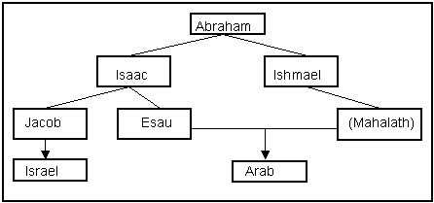

Abraham's Middle East
Middle East During the Time of the Patriarchs
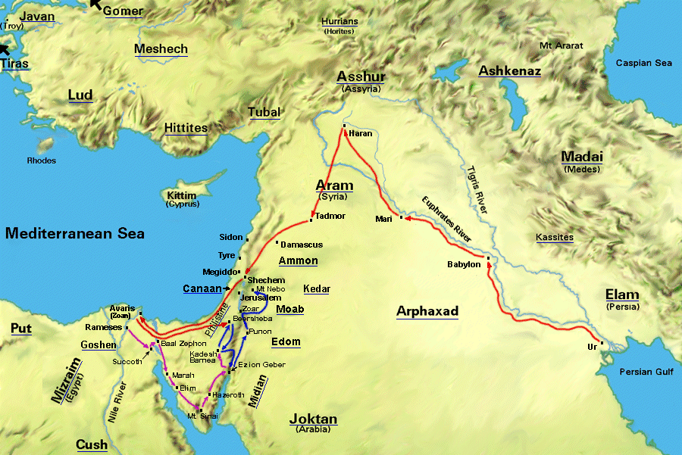

—Maps (Bible Explorer)

Q: What name did Hagar give to the Lord? (Genesis 16:13-14 … see footnote)
Old Testament Timeline
Matthew McGee
Event | Year from Creation | Year of Event | Years Until Next Event | Verses
Birth of Abraham | 1949 | 2001 BC | 75 | Genesis 12:4
Abraham leaves Haran | 2024 | 1926 BC | 11 | Genesis 16:16
Birth of Ishmael | 2035 | 1915 BC | 14 | Genesis 21:5

Genesis 17

Q: Abram is 99 years old. How many years have passed since …

… Ishmael was born? (Genesis 16:16)

… Abram left Haran? (Genesis 12:4)

Q: How old is Sarai? (Genesis 17:17)

Q: What has still not happened for Abram and Sarai? What has compounded the
problem?

Q: How long has it apparently been since the Lord spoke to Abram? (Genesis 15)

Q: In all likelihood, based on what God had told them before and considering their age,
what was their point of view regarding their descendents?

Q: Who appears to Abram? (Genesis 17:1 … see footnote) Why might God describe
himself in such a way (for the first time!) at this time?

Q: What is the Lord’s purpose for appearing to Abram? (Genesis 17:2)

Q: A covenant is a solemn agreement. What does God promise (re-promise) to do for
Abram? Are there any new revelations here?

- (17:4-5)

- (17:6)

- (17:6)

- (17:7)

- (17:8)

- (17:15-16)

- (17:16)

- (17:16)

- (17:19)

- (17:19)

- (17:19)

- (17:20)

- (17:20)

- (17:20)

- (17:20)

- (17:21)

Q: Note the verb tense in Genesis 17:5. Comment in its significance, if any.

Q: Explain how Genesis 17:7-8 is fulfilled.

… God promises to be Abram’s descendents God forever (17:17) (Gal. 3:26-29)

… God promises the land of Canaan (17:18) (Hebrews 11:13-16)

Q: Why were the words in Genesis 17:19b important words for Abram to hear?
Q: What is Abram’s part of the covenant with God? (Genesis 17:10-11)

Q: Who is to be circumcised? (Genesis 17:12-13)

Q: When was this to be done? (Genesis 17:12)

Q: Usually a covenant would be inscribed onto clay. Where was this one inscribed?
(Genesis 17:13)

Q: Among other things, circumcision represented a “setting aside” of God’s people.
What were some of the obvious messages to God’s people through this rite?

1)

2)

3)

4) (Jeremiah 4:4a)

Circumcision in the Ancient Near East
Circumcision, cutting off the male foreskin, was rather common in Abraham's world. The earliest evidence we have for circumcision is from a number of bronze statuettes found at Tell Judeideh in northern Syria, dating to about 2800 BC. The Scripture lists the cultures that practiced circumcision in Jeremiah's day:
"'The days are coming,' declares the Lord, 'when I will punish all who are circumcised only in the flesh -- Egypt, Judah, Edom, Ammon, Moab and all who live in the desert in distant places. For all these nations are really uncircumcised, and even the whole house of Israel is uncircumcised in heart.'" (Jeremiah 9:25-26)
An ivory found at Megiddo (14th or 13th century BC) shows Canaanite prisoners who are circumcised. Circumcision does not seem to have been practiced in Babylonia, Assyria, or by the Philistines. Thus David speaks scornfully of the Philistine Goliath: "Who is this uncircumcised Philistine that he should defy the armies of the living God?" (1 Samuel 17:26).
Other nations, however, administered circumcision at puberty or as a prenuptial ceremony, with the idea of [physical] purification. In contrast, God instructs Abraham to circumcise a male infant on his eighth day (17:12; 21:4; Leviticus 12:3; Luke 1:59) as a sign of the covenant, [a spiritual purification]. For other nations, circumcision may be a sign of purification [only], but for Abraham and his descendents [it was more.] It was to a sign of a unique relationship with God.
[modified slightly from] Joyful Heart Renewal Ministries – JesusWalk Bible study
Q: What was the ramification of neglecting the covenant? (17:14) (Ex. 4:24-26)

Q: Are New Testament Christians still bound to the circumcision covenant?
(Galatians 5:1-6)

Q: God gives Abram and Sarai new names to reflect the certainty of God’s promises.
Compare the meaning of the names.

Abram means __________________ Abraham means _________________

Sarai means __________________ Sarah means __________________

Q: Why did Abraham laugh at God’s promise to give him and Sarah a son? (17:17-18)

Defend your answer from the context.

What does the rest of Scripture show us? (Romans 4:19-21, Hebrews 11:11)

Q: How did Abram respond to God’s covenant promises and demand? (17:23-27)

Points for us to ponder:

- Why doesn’t God appear to us like he appeared to Abram and the Israelites? (Acts 17:24-18, Romans 8:38-39, Hebrews 11:1-2)

- Agree or disagree: the people of the Old Testament and the people of the New Testament are saved in the same way. (Genesis 15:6, Galatians 3:6-9)

- Do we ever doubt God’s promises and try to take things into our own hands? Why does this happen? (Isaiah 55:8-9, 2 Peter 3:8-9, Matthew 14:31) How does trying to take over for God usually turn out? (James 4:1-3)

- Reflect on the similarities and differences between circumcision and baptism.

Similarities:

Differences:

