Monumental Moments in Early
Old Testament History
Poor Choices (Part 1)

Genesis 12:10-20

Q: Why did Abram leave the land promised to him?

Q: Was this a poor choice on his part, demonstrating a lack of faith? Why or why not?
1.
2.
3.
Abram's Journey to Egypt
A famine could cause the loss of a shepherd's wealth. So Abram traveled through the Negev to Egypt, where there was plenty of food and good land for his flocks.

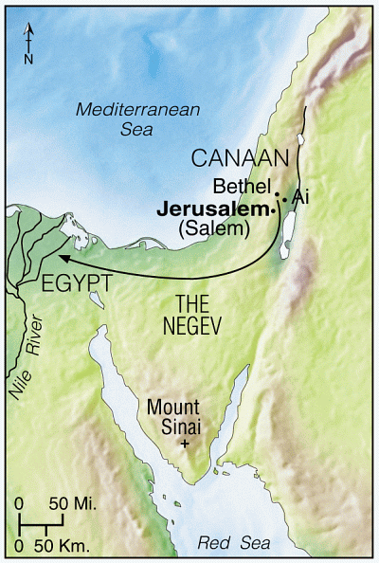
Copyright © 2001 by Tyndale House Publishers
—Tyndale Handbook of Bible Charts & Maps

Q: Roughly how far is it from Bethel to Egypt?

Q: What instructions did Abram give his wife before they entered Egypt? Why?
Q: Was this a poor choice on his part, demonstrating a lack of faith? Why or why not?

Q: Why is it especially astonishing? (Genesis 12:2-3, 7)

Q: Humanly speaking, why perhaps might Abram have wavered here? (This is not
excusing his sin in any way!)

Q: Do you suppose Abram tried to justify this decision in his mind? (Gen. 20:11-12)

Q: Was Sarai innocent in this situation? (After all, it was a strongly patriarchal society.)

Q: What was the risk of the deception?

Q: How did this scenario play out for Sarai? For Abram?
Sarai (12:14-15 &19) …
Abram (12:16 ) …

Q: How do you suppose Sarai is feeling about this? What about Abram?
Sarai …
Abram …

Q: What were the chances of Abram and Sarai being reunited?

Q: What were the potential ramifications of this turn of events?

Q: Since Abram had made such a mess of things, God intervened. How?

Q: Is it safe to assume that Sarai retained her purity through this mess? (Genesis 12:17,
Genesis 20:6)

Q: How did Pharaoh discover the truth? (Genesis12:18) (see also Gen. 20:1-7)

Q: Based on Genesis 20, had Abram learned his lesson here?

Q: What was the final result of Abram’s deception? (Genesis 12:19-20)

Q: What is bitterly ironic about this conversation?

Q: What could have been the final result? What only, perhaps, kept Pharaoh from
imposing this sentence?

Q: In fact, what additional precaution did Pharaoh take regarding Abram and Sarai?
(Genesis 12:20)

Q: Both unbelieving Pharaoh and Abimilech were essentially innocent of wrongdoing
(except perhaps of lust and bigamy). Abram, on the other hand, was guilty of
deception and lack of trust in God. Yet how did God award “legal damages?”

Genesis 13

Q: Where did Abram end up after leaving Egypt? (Genesis 13:3)

Q: What did Abram do when he was there?

Q: Do you suppose repentance was a part of his worship at this time?

Q: What are Abram and Lot’s financial status at this point? (Genesis 13:2, 5)

Q: Large herds were not unusual for wandering shepherds. But what else did Abram
have that was unusual for a nomad?

Q: What challenges does the wealth of uncle and nephew present? (Genesis 13:6-7)
1.
2.

Q: There is an additional factor in this dilemma as well. What? (Genesis 13:7)

Q: How does Abram propose they solve this problem? (Genesis 13:8-9)

Q: Who will make the decision on where the groups go? Why could it be strongly
argued that Lot should have deferred to Abram? (Genesis 12:7)

Q: So what did Lot decide? Why? (Genesis 13:10-12) (See the map on the next page.)
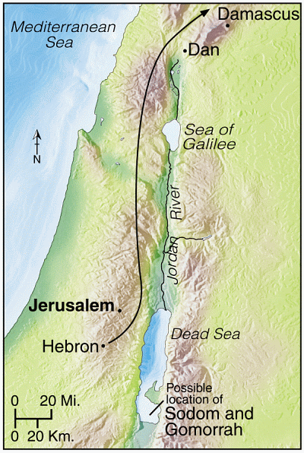

Copyright © 2001 by Tyndale House Publishers
—Tyndale Handbook of Bible Charts & Maps

Q: Was this a good choice? Why or why not? (Genesis 13:13)

Q: Abram and his family’s life would now be more difficult than Lots. Was this actually
a blessing in disguise? If so, how?

Q: Might Abram have had second thoughts about letting Lot choose? Why?

Q: God reassures Abram. (Gen. 13:14-16) What twofold promise does God give him?
1.
2. (note the vivid picture!)

Q: The word “forever” (13:15) is better translated “an indefinitely long time.” How do
we know this is the proper translation? (Deuteronomy 30:17-18)

Q: The only problem is …

Q: The Lord also gives some advice (a command, actually) to Abram. What is it?

Q: Can you think of some reasons why God would tell Abram to do this?
1.
2.
3.
Genesis 14:1-17

Q: Review: What was the first negative ramification of Lot’s choice.

Q: Now comes the second. What is it?

Q: Summarize the situation. (Genesis 14:4)

Q: What did the alliance of the 4 kings do before they came against the rebels? (14:5-7)
(See also the map below.)

Q: Can you discern why the eastern kings might take the route they did?
1.
2.

Q: An interesting side note: this is the first _____________ recorded in the Bible.

Q: Where was the battle against the rebels fought? (Genesis 14:3&10)

Q: What was the result of the battle?
1.
2.
3.

Q: What was carried away from Sodom and Gomorrah? (Genesis 14:11-12)
1.
2.
3. (Genesis 14:16)
4.

Q: Where was Abram at this time? (Genesis 13:18 & 14:13)

Q: Why wasn’t he aware of what had happened? (See the map on page 5.)

Q: How did Abram find out? (Genesis 14:13)

Q: This is the first time Abram is referred to as “the Hebrew.” The designation literally
means “the man from across the river.” What is the river? What is the implication?

Q: What did he decide to do? (Genesis 14:14) From a tactical perspective, why did this
border on madness?

Q: What factors, however, were in his favor?
1.
2.
3.
4. (Genesis 12:2-3)

Q: What additional tactical decisions did he make to benefit his men? (Genesis 14:15)
1.
2.

Q: What was the result of Abram’s attack? (Genesis 14:15-16)
1.
2.
3.
4.
5.

Q: In Egypt, Abram acted rather cowardly. Here we see him in a different light. How
do you explain the two totally different responses?

Genesis 14:18-24

Q: Who comes out to meet Abram after he returns?

Q: Why did he come out to meet Abram?
1. (Genesis 14:18)
2. (Genesis 14:19)

Q: The billion dollar question: Who was Melchizedek?
- (Genesis 14:18)
- (Genesis 14:18)
- (Psalm 110:4) (Hebrews 6:20 & 7:3)

Q: How is Melchizedek a “type” of Christ?
- (Hebrews 7:1)
- (Hebrews 7:2)
- (Hebrews 7:2)
- (Hebrews 7:3)
- (Hebrews 7:3)
- (Hebrews 7:3)
- (Hebrews 7:3)
- (Hebrews 5:10, 6:20, 7:3)

Q: Who was the greater man … Abram or Melchizedek?

Q: How do we know?
- (Hebrews 7:4&6)
- (Hebrews 7:6-7)

Q: Meanwhile, the king of Sodom is also present. What does he offer Abram? (14:21)

Q: What is Abram’s response … and why?
1. (Genesis 14:22-23)
2. (Genesis 14:23)

Q: Abram took gifts from and gave gifts to Melchizedek, but refused gifts from the king
of Sodom. What does this show about their relationships?

Q: What did he agree to take from the king of Sodom? (Genesis 14:24)
1.
2.

Points for us to ponder:

- Can you see any reason why God would show us great men and women of faith struggling in their walk with God (making poor choices)? (Ecclesiastes 7:20)

- When we neglect to trust in God to resolve our difficulties, to what other alternatives must we resort? (Proverbs 3:5-8) And when we make this choice, what is often the result?

- What lessons can we learn about resolving conflict from Abram’s wonderful example? (Genesis 13:8-9) (1 Corinthians 13:4-8)

- Are choices made for obvious blessings always the best choices? What must we always do as we make choices … and especially when an opportunity seems too good to be true? (Ephesians 5:8-11, 1 Thessalonians 5:21-22)

